Product Dashboard - Full Stack MERN Application

Introduction
Milestone-2 focuses on building a single integrated full-stack web application using React for the frontend and Express.js for the backend.
The objective of this project is to demonstrate knowledge of component-based architecture, state management, routing, form validation, and REST API integration.
The developed application is a Product Dashboard that allows users to view products, see detailed information, add new products, and manage favorite status.

Objectives of the Project
- To create a product catalog using React components
- To implement routing between pages
- To integrate frontend with backend APIs
- To validate forms using Formik and Yup
- To manage global state using Context API
- To demonstrate lazy loading as a bonus feature

Technologies Used
Frontend Technologies
- React
- React Router DOM
- Formik
- Yup
- Context API
- Bootstrap

Backend Technologies
- Node.js
- Express.js
- Cors

Project Structure
REETHUM-MILESTONE2-FULLSTACKMERN/
backend/
├── node_modules/
├── package.json
├── package-lock.json
└── server.js
frontend/
├── node_modules/
├── public/
└── src/
├── components/
│ ├── AddProductForm.js
│ ├── ProductCard.js
│ ├── ProductDetail.js
│ └── ProductList.js
├── context/
│ └── ProductContext.js
├── App.js
├── index.js
└── index.css

Backend Implementation
The backend is implemented using Express.js and provides REST APIs to manage products.
API Endpoints
Method | Endpoint | Description
GET | /products | Fetch all products
GET | /products/:id | Fetch product by ID
POST | /products | Add a new product
The backend stores product data in memory and supports JSON request handling and CORS.

Frontend Implementation
The frontend is developed using React and follows a component-based architecture.

User Story 1 - Product Catalog
Description
This user story focuses on displaying a list of products.
Implementation Details
- ProductList is implemented as a class component
- ProductCard is implemented as a functional component
- Product data is passed using props
- Bootstrap cards are used for UI
- Favorite status is managed using React state inside the component

Output
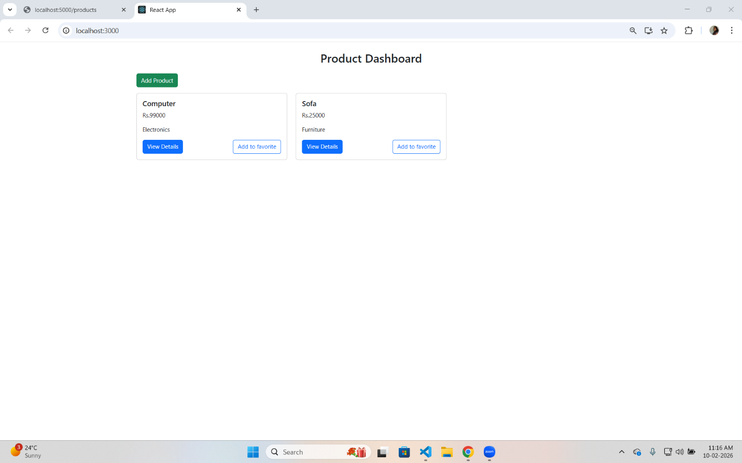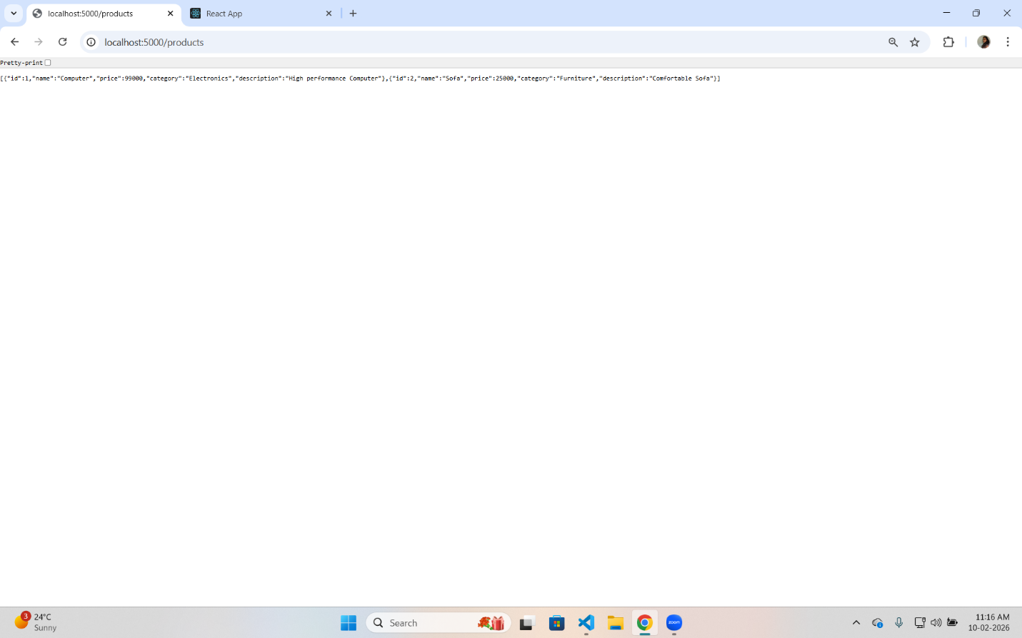
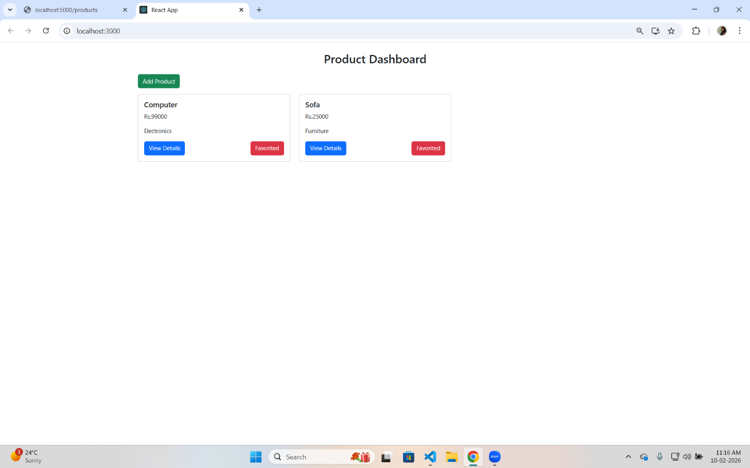

User Story 2 - Routing and Product Details
Description
This user story focuses on navigation and detailed product view.
Implementation Details
- React Router is used for routing
- Dynamic route /product/:id is implemented
- Product details are fetched from backend
- Loading state is displayed while fetching data
- Error handling is implemented using try…catch
- Back button is provided for navigation
- Lazy loading is implemented using React.lazy and Suspense (Bonus)

Output
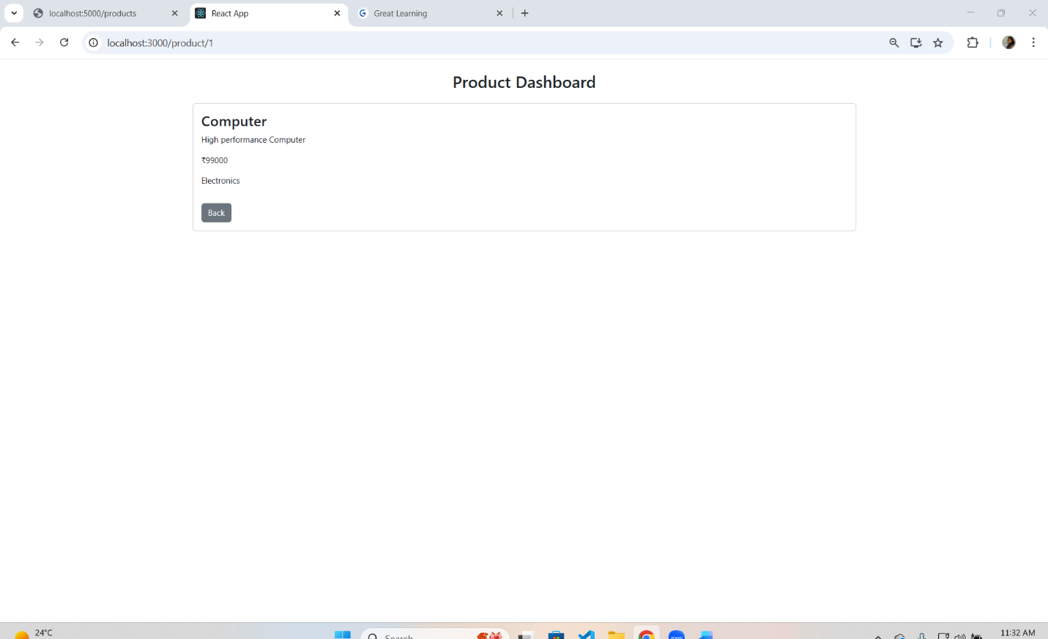
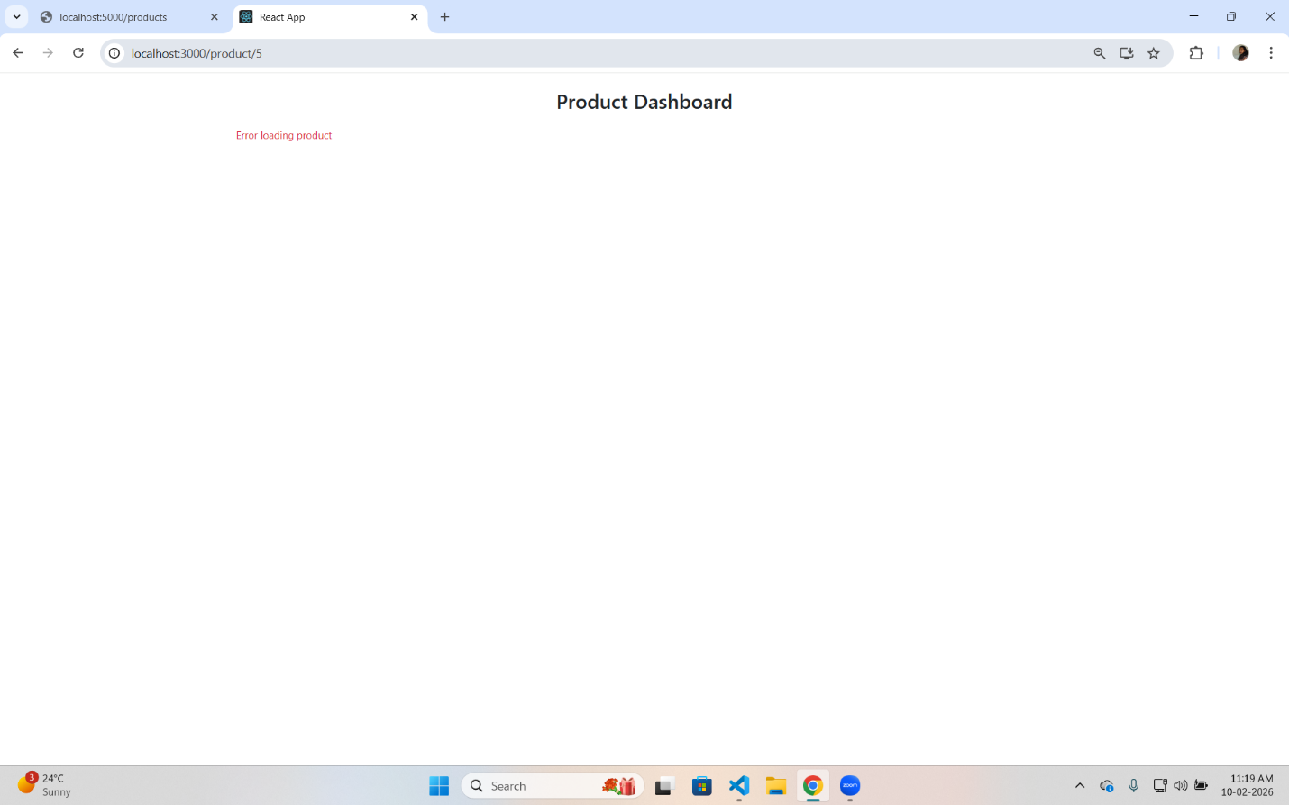

User Story 3 - Add Product Form
Description
This user story focuses on adding new products.
Implementation Details
- Add Product form implemented using Formik
- Form validation handled using Yup
- Fields included:
Name
Price
Category
Description
- Product data is sent to backend using POST API
- Global product list is updated using Context API
- Success message is shown using an alert
- Back button is provided for navigation
Output
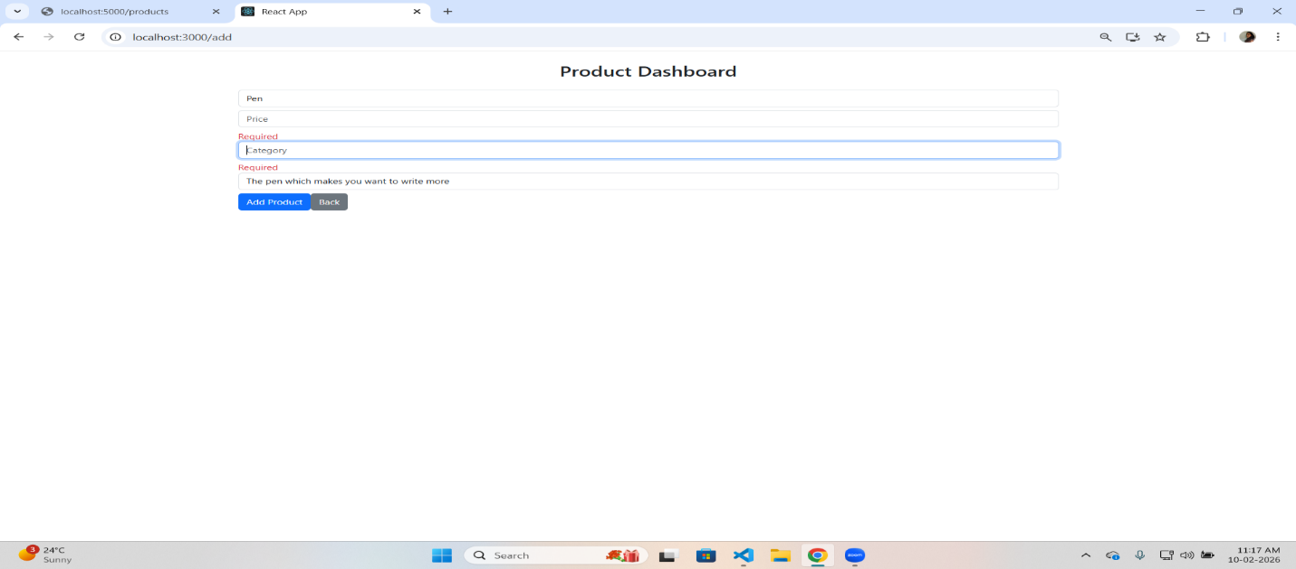
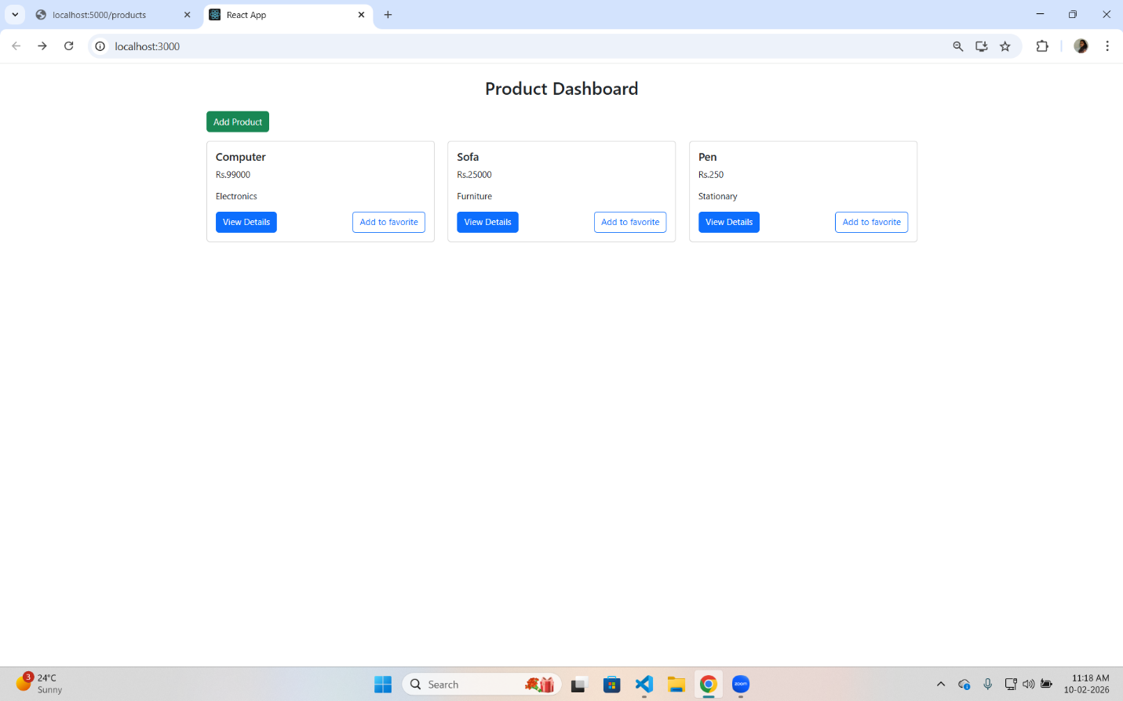
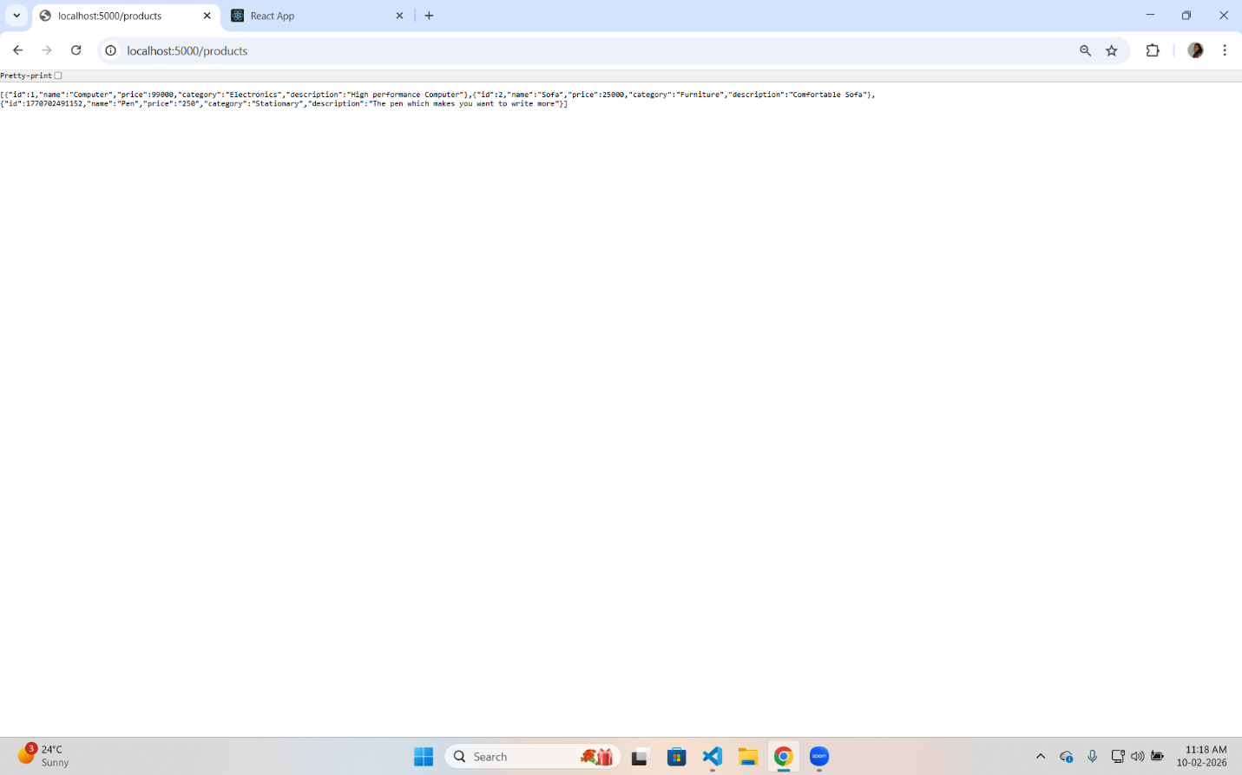

10. Bonus Feature - Lazy Loading
- Product Detail component is lazy loaded
- Improves performance by loading components only when required
- Implemented using React.lazy() and Suspense
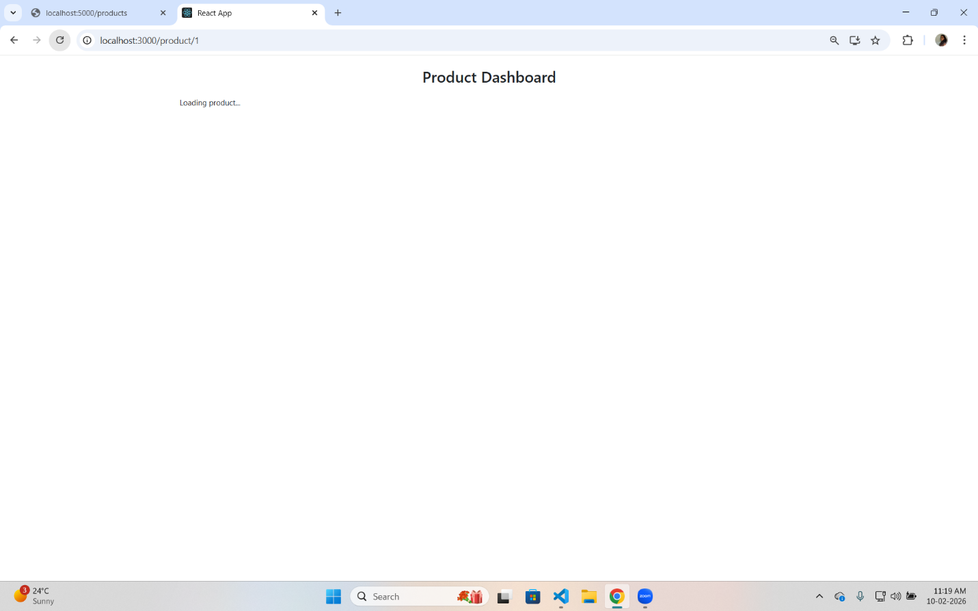

How to Run the Project
Backend
cd backend
npm install
node server.js
Backend runs on http://localhost:5000
Frontend
cd frontend
npm install
npm start
Frontend runs on http://localhost:3000
Conclusion
The Product Dashboard application successfully fulfills all the requirements of Milestone-2.
It demonstrates React fundamentals, routing, form validation, REST API integration, state management, and performance optimization using lazy loading.

